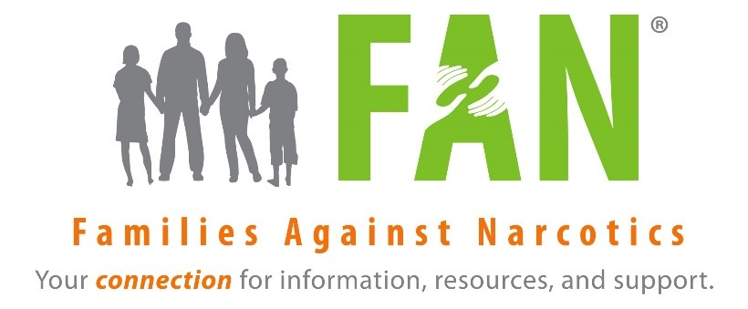
VIRTUAL NALOXONE ACKNOWLEDGEMENT WAIVER (2020 SOR 1)
Please return this completed form to naloxone@familiesagainstnarcotics.org
within 2 days of your training.

Participant certifies that he/she has received training on the indications, use, and administration of Naloxone. Participant agrees to hold Families Against Narcotics Inc. harmless for any incidents that may occur because of the use of the skills learned at this training session. The materials contained in this presentation are provided for general information purposes only and do not represent endorsement for any product or manufacturer.
DATE
KIT # (Leave Blank)
TRAINING LOCATION
NAME
ADDRESS
CITY
STATE
ZIP
EMAIL
PHONE
SIGNATURE
INTERNAL PURPOSES
WITNESS
DATE

